Russell Bjella

ASEN 6008

Homework 1

2/1/2017

1. Patched conic from and to 400 km circular orbits from Earth to Mars
   1. Departure velocity (perihelion of transfer): 32.7279 km/s

Arrival velocity (aphelion of transfer): 21.4795 km/s

* 1. Departure DV: 3.5691 km/s

Arrival DV: 2.0818 km/s

* 1. Time of flight: 258.878 solar days

1. 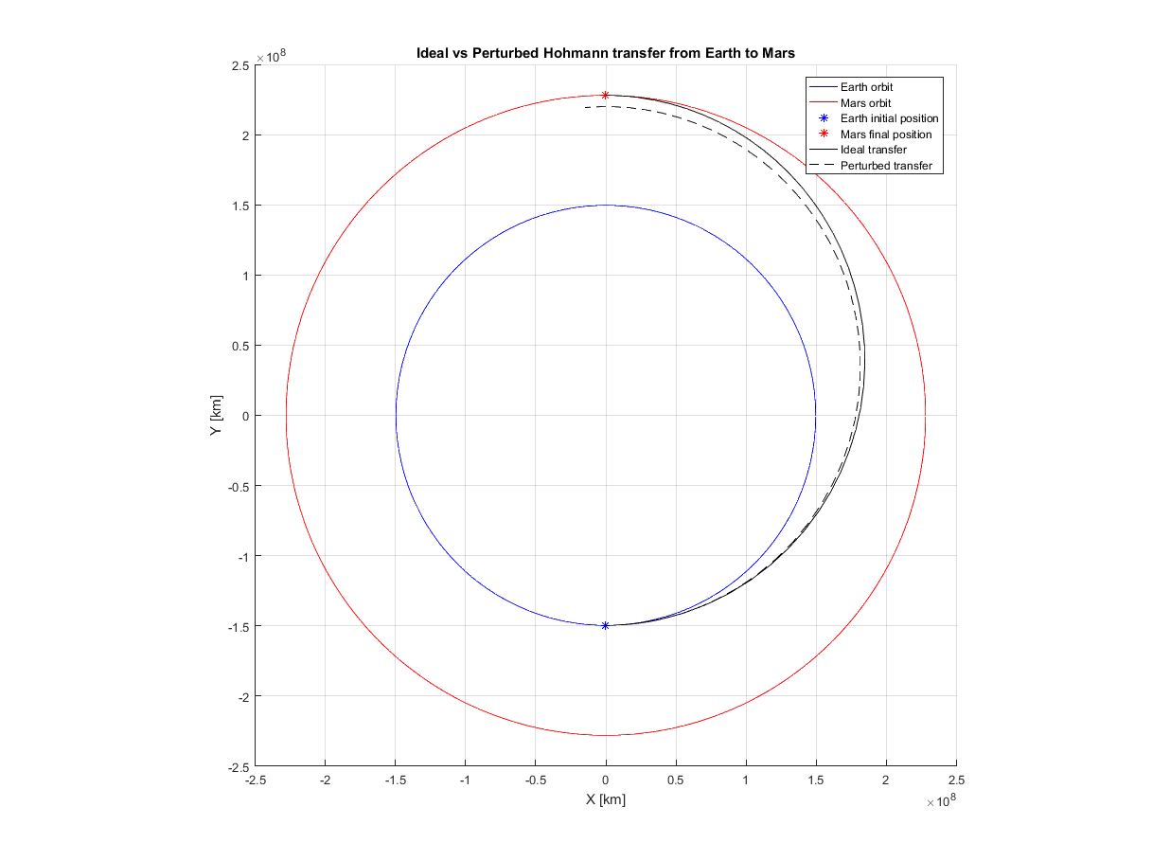Plots of the transfer comparison and error in position and velocity are provided below. Note that in my code, I backed out the initial state of Mars using the mean motion of Mars and the two-body equations of motion. I did this because I needed an initial condition to provide to ode45 for Mars, Earth, and the spacecraft to numerically integrate all three trajectories.

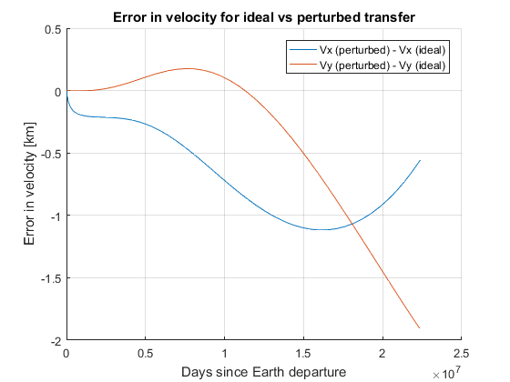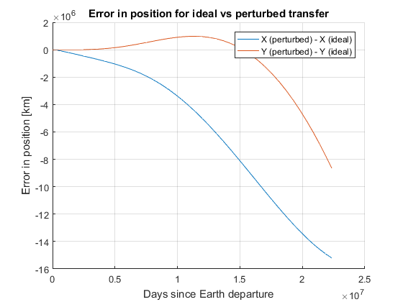The reason the velocities and positions diverge between the two cases (ideal versus perturbed) is because the gravitational pull of the Earth is significant when compared to that of the sun just after departure (it is present throughout the trajectory, just strongest near perihelion). Likewise, the gravitational influence of Mars before the actual encounter is also significant. This results in substantial accelerations being applied to the spacecraft in addition to that of the sun.